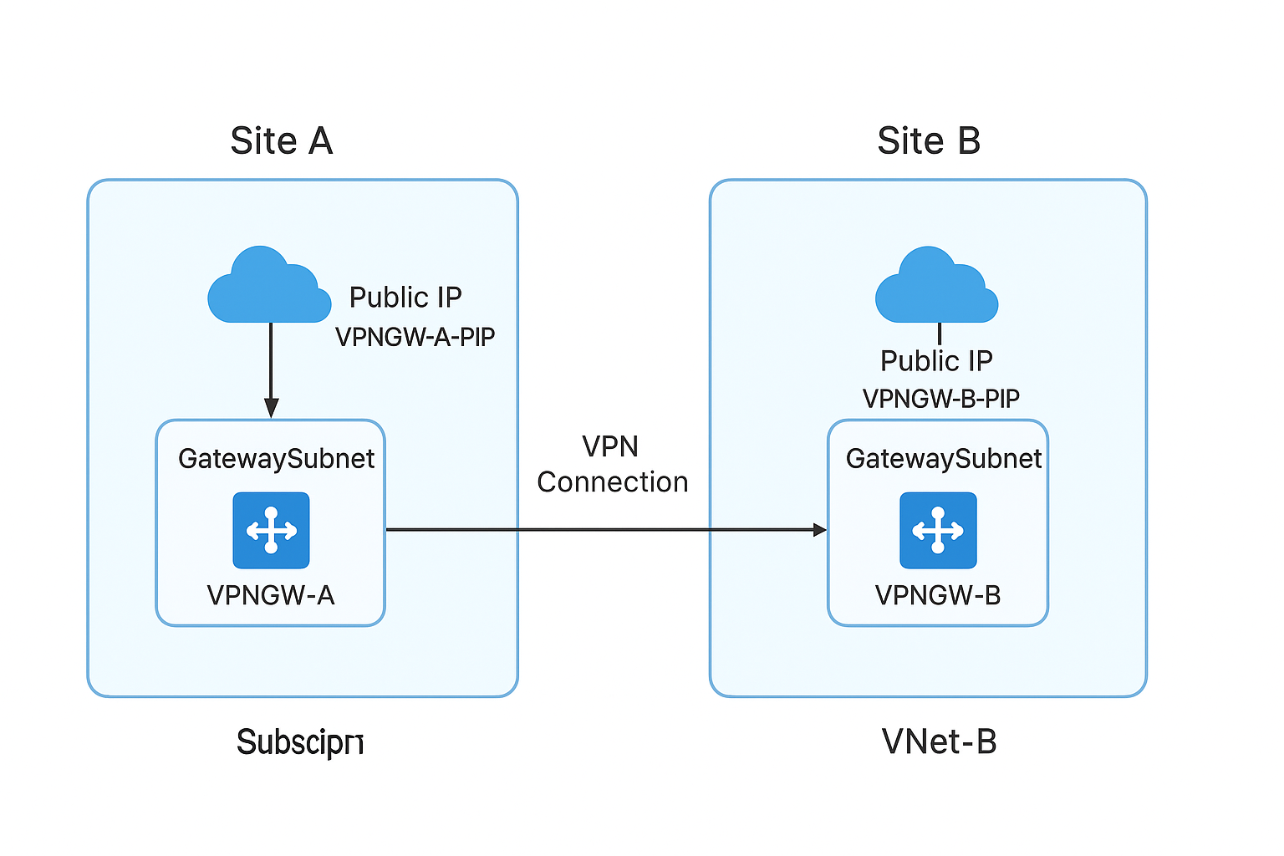
⭐ Final Architecture (to keep it super clear)
Tenant A (Subscription A) Tenant B (Subscription B)
───────────────────────── ─────────────────────────
VNet-A (10.1.0.0/16) VNet-B (10.2.0.0/16)
│ │
VPN Gateway A VPN Gateway B
│ │
└─────────────── IPsec / IKEv2 Tunnel ─────────────┘
- No tenant trust required
- No identity federation
- No need for cross-tenant permissions
- Just plain IPsec Site-to-Site VPN
This is as real as hybrid + partner networking gets.

⭐ Step-by-step Implementation (Full Guide)
🟦 STEP 1 — Create VNet in Subscription A (Tenant A)
Tenant A → Portal
- Create Resource Group:
rg-vpn-a
- Create Virtual Network:
  - Name: vnet-a
  - Region: your choice (e.g., East US)
  - Address space: 10.1.0.0/16
- Add subnets:
  - default → 10.1.1.0/24
  - GatewaySubnet → 10.1.255.0/27
⚠ MUST be exactly GatewaySubnet

🟦 STEP 2 — Create VNet in Subscription B (Tenant B)
Tenant B → Portal
- Resource Group:
rg-vpn-b
- Virtual Network:
  - Name: vnet-b
  - Region: same or different region is fine
  - Address space: 10.2.0.0/16
- Subnets:
  - default → 10.2.1.0/24
  - GatewaySubnet → 10.2.255.0/27

🟦 STEP 3 — Create VPN Gateway in Both Tenants
⭐ In Tenant A
- Create Virtual Network Gateway
  - Name: gw-vnet-a
  - Region: same as VNet
  - Gateway type: VPN
  - VPN type: Route-based
  - SKU: VpnGw1 (recommended)
  - Public IP: new → pip-gw-a
  - VNet: vnet-a
⏳ Takes 25–45 min.
⭐ In Tenant B
- Create Virtual Network Gateway
  - Name: gw-vnet-b
  - Gateway type: VPN
  - VPN type: Route-based
  - SKU: VpnGw1
  - Public IP: new → pip-gw-b
  - VNet: vnet-b
⏳ Also 25–45 min.

🟦 STEP 4 — Create Local Network Gateway (LNG) in Both Tenants
Think of an LNG as:
“Azure… this is where the OTHER network lives.”

⭐ In Tenant A → create LNG for Tenant B
Local Network Gateway A
- Name: lng-b
- IP address: Public IP of gw-vnet-b
- Address space:
- 10.2.0.0/16

⭐ In Tenant B → create LNG for Tenant A
Local Network Gateway B
- Name: lng-a
- IP address: Public IP of gw-vnet-a
- Address space:
- 10.1.0.0/16

🟦 STEP 5 — Create the VPN Connections (Tunnel)
Important:
The shared key MUST MATCH on both sides.
Let’s pick a simple shared key:
MyStrongKey123!

⭐ In Tenant A
Go to gw-vnet-a → Connections → + Add
- Name: conn-a-to-b
- Connection type: Site-to-Site (IPsec)
- Local network gateway: lng-b
- Shared key: MyStrongKey123!

⭐ In Tenant B
Go to gw-vnet-b → Connections → + Add
- Name: conn-b-to-a
- Connection type: Site-to-Site (IPsec)
- Local network gateway: lng-a
- Shared key: SAME key
MyStrongKey123!

🟦 STEP 6 — Wait for Tunnel to Connect
Usually 30–60 seconds once both sides are configured.
In both tenants:
Virtual Network Gateway → Connections
Status should become:
Connected
If it's stuck on “Connecting” → usually the shared key doesn’t match.

⭐ STEP 7 — Test Communication
Deploy a VM in VNet A:
- Name: vm-a
- Private IP: e.g. 10.1.1.4
Deploy a VM in VNet B:
- Name: vm-b
- Private IP: e.g. 10.2.1.4
From VM-A:
ping 10.2.1.4
If ICMP blocked, use:
Windows:
Test-NetConnection 10.2.1.4 -Port 22
Linux:
nc -vz 10.2.1.4 22

⭐ STEP 8 — (Optional) Add Routing Table Checks
Azure handles route propagation automatically because these are Route-Based VPN gateways.
You’ll see routes like:
In VNet A:
10.2.0.0/16 → VPN Gateway
In VNet B:
10.1.0.0/16 → VPN Gateway
No extra routing tables or UDR needed.

⭐ Summary (So It’s Crystal Clear)
Component | Tenant A | Tenant B
VNet | 10.1.0.0/16 | 10.2.0.0/16
GatewaySubnet | 10.1.255.0/27 | 10.2.255.0/27
VPN Gateway | gw-vnet-a | gw-vnet-b
Local Network Gateway | lng-b | lng-a
Public IP | pip-gw-a | pip-gw-b
Connection | conn-a-to-b | conn-b-to-a
Shared Key | same on both sides | same

